FIN Inclusion Matters
C O N T A C T S Parents Supporting Parents with Child Safety

f i n q l d t s v @ g m a i l . c o m

0 4 0 2 2 5 4 9 8 4

w w w . f i n-
q l d t s v . o r g . a u

I S S U E 2

A Message from the President

J U L Y 2 0 1 3

P O B o x 1 8 3 9

T o w n s v i l l e 4 8 1 0

Insi de
this Iss ue

CARMODY | 2 - 4
INQUIRY
Highlights
from
FIN Townsville’s Response

FIN runs the 5 May Day Rally BBQ

Your Say 6 - 8

FIN Issue 2 Newsletter editors:

Simon Gadd Ros Thorpe
Since the first issue of our News- letter, Family Inclusion Matters, in November 2012, FIN in Townsville has been active on a number of fronts. First we played an active role in the Peakcare Expo at JCU in November where FIN members and supporters were on most of the discussion panels and FIN Tsv won the “Best Trade Display” award. Then in early December FIN hosted a one day workshop by Terry Steadman from the South West Brisbane Community Legal service on support and advocacy with parents and families when Child Safety intervenes in their lives. This was very well supported by staff from non-government organisations and everyone learned a great deal.
In January, while many other ser- vices were closed or short staffed, FIN was contacted by a number of parents seeking support and we
now have enough volunteers to respond promptly and actively. This level of new contacts has con- tinued so that, as of April 2013, FIN in Townsville is supporting 10 new families and 10 continuing families (total 20) providing information, support at meetings with Child Safety, support with appearances in the Children’s Court and the Family Court, help with Affidavit preparation, help with letter writing, personal support, and practical help.

FIN is very proud of the role which volunteers play as Resourceful Friends (Bob Holman 1983) and I would like to take this opportunity to recognise and thank all those who take on this role within FIN, combining support for families with all the other demands in their lives. Every month FIN Townsville has two sessions of peer support and supervision for supporting volunteers and social work stu- dents from JCU. FIN is especially delighted that many such students choose to remain involved with FIN after their placement has ended.
FIN in Townsville is also keen to maintain a research profile, with two FIN supporting members un- dertaking relevant research studies and FIN members are writing an article on family inclusive child protection practice to be submitted to a special issue of Children Aus- tralia later this year.
In mid-February 2013 the Carmo- dy Commission of Inquiry into the Queensland Child Protection sys- tem issued a Discussion Paper to which FIN Townsville wrote a com- prehensive response and highlights are included on pages 2-4.
Once again FIN Townsville did the BBQ at the 2013 May Day Rally in Townsville (see page 5) with the help of 24 volunteers. FIN also joined the March with our banner and we won the “Best Community
Contingent” award. The profit from the BBQ enables FIN to afford Insurance cover which means we can now apply for funds to better support families and volunteers.
Finally I’d like to thank the current FIN student, Simon Gadd, for pro- ducing this Issue of the FIN News- letter and his initiative in introduc- ing Have Your Say (see pages 6-8). Here you can read how families experience FIN and their ideas for how FIN can grow and develop. We’d like to invite you to have YOUR say for the next Issue of Family Inclusion Matters which we hope to produce in the second half of 2013.

Bob Holman (1983) Resourceful Friends: skills in community social work. UK: The children’s Society.

Ros Thorpe, FIN Tsv President

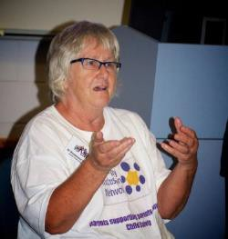
1

FIN Responds to the …..
The QCPCI (Queensland Child Protection Commission Inquiry) was established on the 1st of July, 2012, to review Queensland’s Child Protection System. Out of six terms of reference, the following issues were of particular interest to FIN
- Whether the current use of available resources across the child protection system is adequate and whether resources could be used more efficiently.
- The current Queensland government response to children and families in the child protection system
- The transition of children through, and exiting the child protection system
- Reforms to ensure that the Queensland child protection system achieves the best possible out- comes to protect children and support families.
In early March this year, FIN in Townsville submitted a formal response to the Discussion Paper published by the QCPCI. The following are excerpts from this response.

Q 47: What other changes might improve the Effectiveness of the Qld CP system

- The significance of our place as the biological/natural family of our children in the Australian culture should, we believe, be articulated explicitly in the final Recommendations of the Carmody Inquiry.

“The stereotyping of parents as the ‘Baddies’ should be outlawed and respect for our dignity and worth should be endorsed”.
We should always be perceived as important even at times when we may have fallen short of society’s standards of “good enough” care for our children.

- In the experience of FIN in Townsville, parents and grandparents benefit enormously from the availability of support with court proceedings (when legal representation is not possible) and in meetings with Child Safety staff. Without this support many of us feel disempowered to the point of giving up or becoming unhelpfully angry. In our view, FIN type volunteers should be available outside every Children’s court in the state.

Finally, at the level of general comments on the Discussion paper (in response to Q 47), we have to express our disappointment that the proposed changes fall short of a truly radical transformation of the Queensland child safety system. Our preference would be for the system to resemble more the family and child well- being systems in Scandinavian and continental European countries (excluding the UK), both in substance and through a name change more attuned with promoting family wellbeing rather than an essentially narrow focus on child safety.

2

Carmody Inquiry

Q 6. How could we improve the system’s response to frequently encountered families?

Some families may need support throughout their children’s childhood, and some at irregular or occasional times of parental ill-health or crisis. This should not be seen as sufficient reason for removal of children into care. The family is where children belong and, if the children are not being harmed in a very serious way, then keeping them at home is far more cost effective.
No negative judgments should be made about this. Interdependency is what all humans need and, where some families cannot access wider family support, then support from community services should be available to take on this role, for short or longer time periods.

Q 7. Is there any scope for uncooperative or repeat users of tertiary services to be compelled to attend a support program as a precondition for keeping their child at home?

There is a need to ensure that the support programs which parents are required to attend are relevant and will be beneficial, rather than simply a means for exercising power and control over parents and making them demonstrate compliance.

Q 8. What changes, if any, should be made to the SDM tools to ensure they work effectively?

One supporting member of FIN has written “I agree wholeheartedly with incorporating Signs of Safety into child protection work. I have done training with Andrew Turnell and whilst a team leader in the Department I would use some of the SOS tools to make sure workers were identifying strengths and weaknesses/challenges in families. Using this approach we managed to keep a baby who had suffered broken bones at home with family and supported by a strong network for over
12 months until he was of an age where the risks were reduced and then the Department involvement ceased. No orders were ever applied for and at no time was removal of the child from his parents contemplated. Family, community and department workers developed a strong working partnership and it was a fabulous outcome for all involved.”

“FIN Townsville is totally opposed to both closed adoption and to the forced termination of parental rights with a view to securing adoption”.

Q 13. Should adoption or some other permanent placement option, be more readily available to enhance placement stability for children in Long Term care?
Additionally, FIN Townsville is opposed to the use of open adoption except in circumstances when it is the birth parents’ first preference, when their parental consent is given freely, and when grandparents’ support is also forthcoming. Adoption only works well if it is truly "voluntary".

3

Response to Carmody Inquiry Cont..
Q 28. Are there specific areas of practice where
training could be improved?
In FIN Townsville’s view there is a need for basic and ongoing training for workers in many areas, including the following:

“In our experience as parents, workers are time poor, power hungry, and manipulate us into agreeing with things we would rather not agree to. We feel powerless because Child Safety have our child.”
  - The true spirit of the 1999 Child Protection Act
  - awareness of POWER dynamics in working relationships
  - working with domestic and family violence
  - working with angry service users

Q 41. What, if any, changes should be made to the FGM process to ensure that it is an effective mechanism for encouraging children, young people, and families to participate in decision making?

Parents in FIN Townsville think that Family Group Meetings should be conducted in the way they were intended – with a spirit of inclusion.
In our experience as parents, workers are time poor, power hungry, and manipulate us into agreeing with things we would rather not agree to. We feel powerless because Child Safety have our child.

Q 46. Where in the Child Protection system can savings or efficiencies be identified?

- Giving families greater support at the time of need
- Not taking so many children into care unnecessarily
- Dealing with neglect and emotional harm through means of family support not removal of children
- cutting back on investigations on perceived risk but no actual harm
- Support after reunification in order to reduce the risk of re-entry into out-of- home care
- Greater accountability re implementing the spirit of the Act would actually lead to savings, as better practice would lead to fewer placement break- downs, fewer young people in care getting caught up in in the youth justice system, etc
- listening to the wishes of children and young people who long to return to their parents’ care and supporting them to do so

FIN INCLUSION MATTERS
If you would like to view the entire FIN Townsville response, check out
www.childprotectioninquiry.qld.gov.au/

4

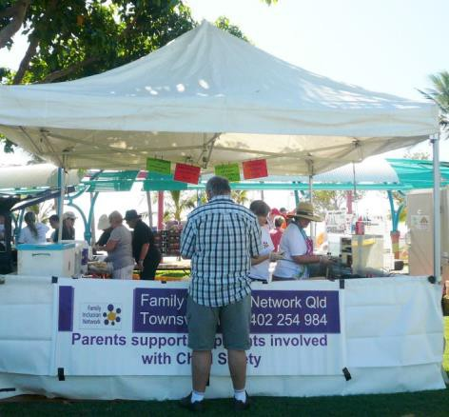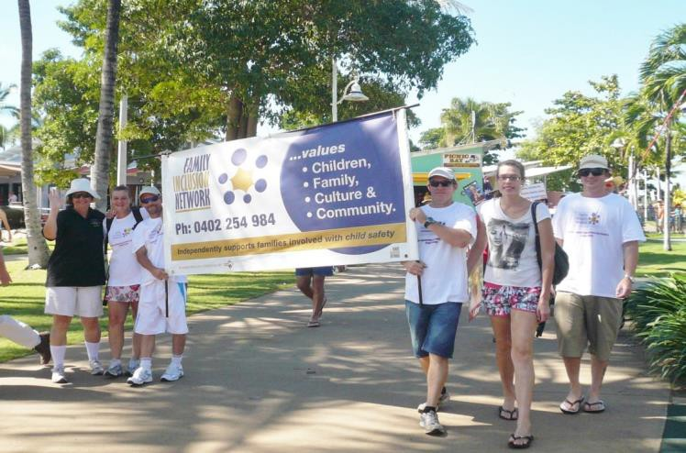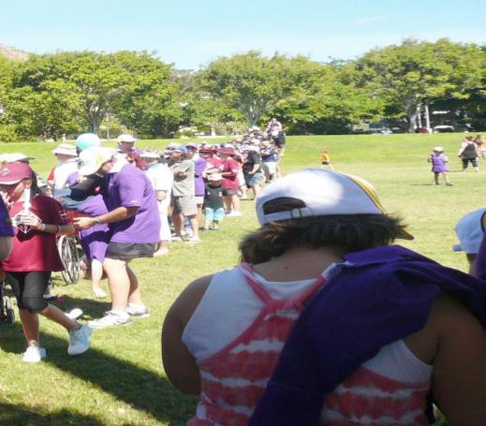

Carrying the FIN Banner!

Pictured from left: Erin, Donna, Gary, Jamie, Emma, Simon
Another Successful May Day BBQ
This year over 20 people volunteered their time to come along and help out with the May Day BBQ and join the march flying the FIN banner for which were awarded The Best Community Organisation Contingent! It was a hectic day but well worth it in the end with some people even getting the option to receive their food handling licence. Thank you to everyone who came along and supported FIN and helped get our name out there and raise enough funds for FIN to afford insurance cover. GREAT JOB!

View from the front
This guy must have got in before the rush!

LOOK AT THAT LINE!
This is a good insight into how busy everyone was!

FIN INCLUSION MATTERS

5

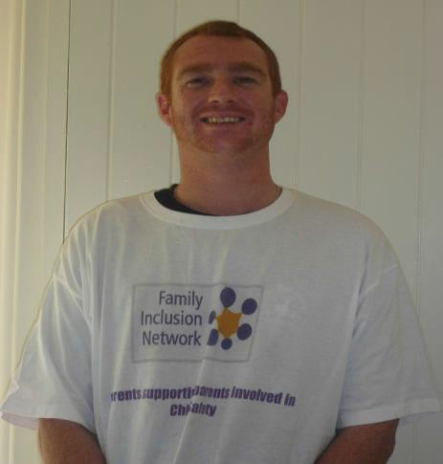Column compiled by Simon Gadd.
In an attempt to gain an insight into the perceptions of FIN in Townsville, from members and volunteers, a short questionnaire was developed with the assistance of the FIN Committee, and I set about offering people a chance to speak up about their experiences with FIN.
The Questionnaire offered a chance to speak about the good, and the not so good, with a mostly positive reaction. The major recurring positive theme was that people using FIN felt that they were not being judged - a far cry from their experiences with the child protection system. The following are excerpts from responses to the questionnaire.

When asked if they had found their contact with FIN useful one parent responded “yes”, through helping with their child and dealing with people “in a polite manner” instead of going off the handle. They expressed that they felt the good things about FIN were that they supported them in meetings with Child Safety and that “they don’t judge who you are”.
One member outlined that they had, like most people who have Child Safety enter their lives, a poor knowledge regarding their rights and legislation. The Family Inclusion Network had been so helpful as they are a wealth of knowledge and were able to point out areas that had been mismanaged or simply incorrect. This member, like others, has outlined the lack of judging from FIN volunteers as extremely important as “my story isn’t great, it’s a shock on people, like I’m harming them when I’m telling the story”. To be around people who can look past this and focus on the true issue at hand has been extremely rewarding for this FIN member.

When asked about things that could be improved about FIN, the reply was that perhaps more needed to be done in regard to marketing FIN.
And for how FIN could be in the future, it was suggested that more people who haven't been affected by Child Safety but have the passion for standing up for people’s rights might become involved.

Another FIN member appreciates the help from FIN, recognising that volunteers (under heavy workloads) did everything they could for them with all available resources. This member adamantly praised FIN for standing up so members were being heard and that they “actually believe what you say”. This member also appreciated the “non-judgmental” nature of FIN.

FIN INCLUSION MATTERS

6

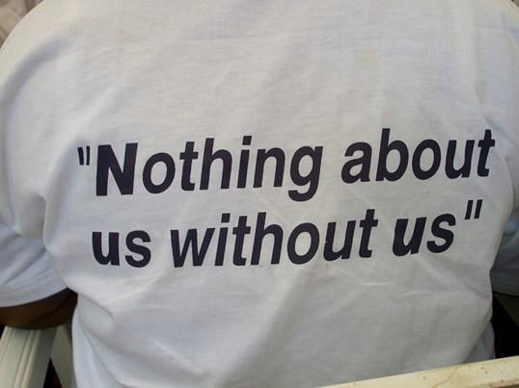

.
A fourth member appreciated the “fact that somebody was out there who understands what the problems are and what they were going through”. They outlined the benefits of being able to meet people who “are in the same boat”, but also to meet professionals who know what support systems are available. This member would like to see FIN recognised more by the media for their commitment to helping people, and would absolutely recommend parents or grandparents to get into contact with FIN. As well, this member hoped for the future that FIN would be funded, with money being available for parents to acquire legal representation.

Volunteer Giovanna noted that the most rewarding thing about working with FIN was learning about “letting go of one’s power over people”, liking the fact that in FIN professionals and non-professionals work alongside parents as equals. Having done her placement for University with FIN, Giovanna boldly states that, whether you are a professional, student or parent, becoming involved with FIN brings you to “the crux of what true social work is … to work with people and not against them”. For the future, as well as funding for FIN, Giovanna would like FIN to become recognised as an activist group, “supporting members is the true essence of achieving human rights and social justice”. Giovanna added that although she has found it challenging at times, it has kept her focus on the real people in need “who are often casualties of other organisations’ policies and procedures”.

FIN volunteer Megan notes that doing her placement with FIN was a life changing experience, by increasing her self-esteem and confidence. Like Giovanna, Megan loves the fact that she is working with people. Her only criticism of FIN is that more trained volunteers are needed to meet the increased needs of parents, grandparents and significant others who are involved with child protection services. When asked if she would encourage other students to get involved with FIN Megan replied, “yes, FIN is an amazing support group which exemplifies the social work values of respecting the inherent dignity and worth of individuals and provides non-judgmental support and advocacy to vulnerable citizens in our society.”

Thank you and well said Megan!

FIN INCLUSION MATTERS

7

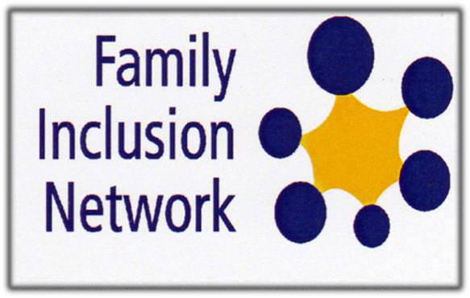

The last word …..

“My interpretation is that Child Safety uses and gets away with the inhumane treatment towards parents because of the public stigma that is attached to parents (as being bad and incapable) who are dealing with child safety.

Child Safety enforce power over approaches (through intimidation and subtle - sometimes not subtle - emotional blackmailing) they use to control parents, because they see themselves as the morality police when it comes to children, by subverting the phrase "in the best interests of the child". Child Safety hides behind regulations and their regulatory powers to justify their actions. Child Safety has no interest in the re-unification of children with parents in the majority of cases and totally disregards the emotional, physical or mental consequence of the damage they cause to the parents and/or their children.”

a supporting FIN volunteer

Family Inclusion Network Queensland Townsville Inc
Assisting parents, grandparents and significant others involved with Child Safety
Contact FIN Townsville for information, support, advocacy, and friendship.
Drop-in morning teas 10.30am every 1st and 3rd Tuesday of each month at 431 Ross River Road, Cranbrook
FIN phone hotline: 0402 254 984 Email: finqldtsv@gmail.com web site: www.fin-qldtsv.org.au

FIN INCLUSION MATTERS
8

